COMPUTER SCIENCE PROJECT FILE

NAME Minissha Thakur

PAYROLL MANAGEMENT SYSTEM


REQUIREMENTS
HARDWARE REQUIREMENT:
Device name DESKTOP-7NR3GI0
Processor Intel(R) Core (TM) i3-8130U CPU @ 2.20GHz 2.20 GHz
Installed RAM 8.00 GB
Device ID 758B4A8F-2523-40E8-BEE2-349BE57D3CEF
Product ID 00330-81486-44873-AA249
System type 64-bit operating system, x64-based processor
Pen and touch Touch support with 2 touchpoints

SOFTWARE REQUIREMENT:
Edition Windows 10 Pro
Version 22H2
Installed on ‎03-‎Oct-‎21
OS build 19045.3693
Experience Windows Feature Experience Pack 1000.19053.1000.0

SYNOPSIS OF THE PROJECT
This project aimed to create a practical and useful program to manage a company system. The Payroll Management System Project is a system used by companies to help manage the computation, disbursement, and reporting of employees’ salaries efficiently and accurately

The program is used for adding records, displaying records, deleting records, modifying records of an employee, and for display of their payroll or salary slips.

The Python program is constructed by incorporating functions, if-else constructs, and integrating a MySQL database.

Upon running the program, the user is presented with a main menu. It contains the following choices a user can opt from.

SOURCE CODE
import mysql.connector as msq
import datetime
from tabulate import tabulate

db=input("Enter name of your database: ")
print()
mydb=msq.connect(host='localhost',user='root',passwd='12345')
mycursor=mydb.cursor()

sql="CREATE DATABASE if not exists %s"% (db,)
mycursor.execute(sql)
print("Database created successfully..")
print()

mycursor=mydb.cursor()
mycursor.execute("use "+db)
TableName=input("Enter the name of the table to be created: ")
print()

query="create table if not exists " + TableName+ "\
(Empno int primary key,\
Name varchar(15) not null,\
job varchar(15),\
BasicSalary int,\
DA float,\
HRA float,\
GrossSalary float,\
Tax float,\
Netsalary float)"
print("Table " +TableName+ " created successfully...")
mycursor.execute(query)

while True:
print('\n\n\n')
print("*"*95)
print('\t\t\t\t\t\t\t\t\tMAIN MENU')
print("*"*95)
print('\t\t\t\t1. Adding employee records')
print('\t\t\t\t2. For Displaying Record of All the Employees')
print('\t\t\t\t3. For Displaying Record of a particular Employee')
print('\t\t\t\t4. For deleting Records of all the Employees')
print('\t\t\t\t5. For deleting a Record of a particular employee')
print('\t\t\t\t6. For modification in a record')
print('\t\t\t\t7. For displaying payroll')
print('\t\t\t\t8. For displaying Salary Slip for all the Employees')
print('\t\t\t\t9. For displaying Salary slip for a particular Employee')
print('\t\t\t\t10.For exit')
choice=int(input('Enter your choice: '))
print()
if choice==1:
try:
print('Enter Employee information...')
mempno=int(input('Enter employee no: '))
mname=input('Enter employee name: ')
mjob=input('Enter employee job: ')
mbasic=float(input('Enter basic salary: '))
if mjob.upper()=='OFFICER':
mda=mbasic*0.5
mhra=mbasic*0.35
mtax=mbasic*0.2
elif mjob.upper()=='MANAGER':
mda=mbasic*0.45
mhra=mbasic*0.30
mtax=mbasic*0.15
else:
mda=mbasic*0.40
mhra=mbasic*0.25
mtax=mbasic*0.1
mgross=mbasic+mda+mhra
mnet=mgross-mtax
rec=(mempno,mname,mjob,mbasic,mda,mhra,mgross,mtax,mnet)
query="insert into "+TableName+" values (%s,%s,%s,%s,%s,%s,%s,%s,%s)"
mycursor.execute(query,rec)

mydb.commit()
print("record added successfully...")
except Exception as e:
print("Something went wrong",e)

elif choice==2:
try:
query='select * from '+TableName
mycursor.execute(query)
myrecords=mycursor.fetchall()
print(tabulate(myrecords,headers=['Empno','Name','Job','Basic salary','DA','HRA','Gross Salary','Tax','Net Salary']))
except:
print("SOMETHING WENT WRONG")

elif choice==3:
try:
en=input('enter employee no to be displayed...')
query="select * from "+TableName+" where empno=" +en
mycursor.execute(query)
myrecord=mycursor.fetchone()
print("\n\nRecord of Employee No: "+en)
print(myrecord)
c=mycursor.rowcount
if c==-1:
print("nothing to display")
except:
print('SOMETHING WENT WRONG')

elif choice==4:
try:
ch=input("do you want to delete all the records (Y/N)---")
if ch.upper()=="Y":
mycursor.execute('delete from '+TableName)
mydb.commit()
print("all the records are deleted...")
except:
print("SOMETHING WENT WRONG")

elif choice==5:
try:
en=input('enter employee no. of the record to be deleted..')
query='delete from '+TableName+' where empno='+en
mycursor.execute(query)
mydb.commit()
c=mycursor.rowcount
if c>0:
print("DELETION DONE")
else:
print("employee no ",en," not found ")
except:
print("SOMETHING WENT WRONG")

elif choice==6:
try:
en=input("enter employee number, of whom the record to be modified...")
query="select * from " +TableName+ " where empno="+en
mycursor.execute(query)
myrecord=mycursor.fetchone()
c=mycursor.rowcount
if c==-1:
print('empno '+en+' does not exist')
else:
mname=myrecord[1]
mjob=myrecord[2]
mbasic=myrecord[3]
print('empno :',myrecord[0])
print('name :',myrecord[1])
print('job :',myrecord[2])
print('basic :',myrecord[3])
print('da :',myrecord[4])
print('hra :',myrecord[5])
print('gross :',myrecord[6])
print('tax :',myrecord[7])
print('net :',myrecord[8])
print('-----------------------')
print('Type value below to modify or just press enter for no change')
x=input('enter name ')
if len(x)>0:
mname=x
x=input('enter job ')
if len(x)>0:
myjob=x
x=input('enter basic salary ')
if len(x)>0:
mbasic=float(x)
query='update '+TableName+' set name='+"'" +mname+"'"+','+' job='+"'"+mjob+"'"+','+'basicsalary='\
+str(mbasic)+' where empno='+en
print(query)
mycursor.execute(query)
mydb.commit()
print('record modified')

except:
print('SOMETHING WENT WRONG')

elif choice==7:
try:
query='select * from '+TableName
mycursor.execute(query)
myrecords=mycursor.fetchall()
print("\n\n\n")
print(95*'*')
print('EMPLOYEE PAYROLL'.center(90))
print(95*'*')
now=datetime.datetime.now()
print("current date and time:",end=' ')
print(now.strftime("%Y-%m-%d %H:%M:%S"))
print()
print(95*'-')
print('%-5s %-15s %-10s %-8s %-8s %-8s %-9s %-8s %-9s'\
%('Empno','Name','Job','Basic','DA','HRA','Gross','Tax','Net'))
print(95*'-')
for rec in myrecords:
print('%4d %-15s %-10s %8.2f %8.2f %8.2f %9.2f %8.2f %9.2f'%rec)
print(95*'-')
except:
print("SOMETHING WENT WRONG")

elif choice==8:
try:
query='select * from '+TableName
mycursor.execute(query)
now=datetime.datetime.now()
print("\n\n\n")
print('-'*95)
print('\t\t\t\tSalary slip')
print('-'*95)
print("current date and time:",end='')
print(now.strftime("%Y-%m-%d %H:%M:%S"))
myrecords=mycursor.fetchall()
for rec in myrecords:
print('%4d %-15s %-10s %8.2f %8.2f %8.2f %9.2f %8.2f %9.2f'%rec)
except:
print("SOMETHING WENT WRONG")

elif choice==9:
try:
en=input("enter employee number whose pay slip you want to retrieve: ")
query="select * from " +TableName+" where empno=" +en
mycursor.execute(query)
now = datetime.datetime.now()
print("\n\n\n\t\t\t\tSALARY SLIP ")
print("current date and time:",end=' ')
print(now.strftime("%Y-%m-%d %H:%M:%S"))
print(tabulate(mycursor, headers=['Empno','Name','Job','Basic salary','DA','HRA','Gross Salary','Tax','Net Salary']))

except Exception as e:
print("SOMETHING WENT WRONG",e)

elif choice==10:
break
else:
print("wrong choice...........")

OUTPUT
After running the program

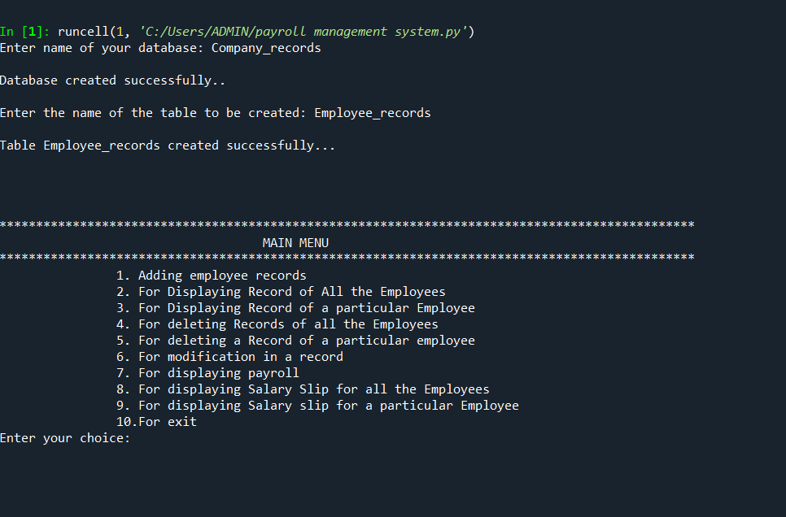

On choosing option 1-
Employee information
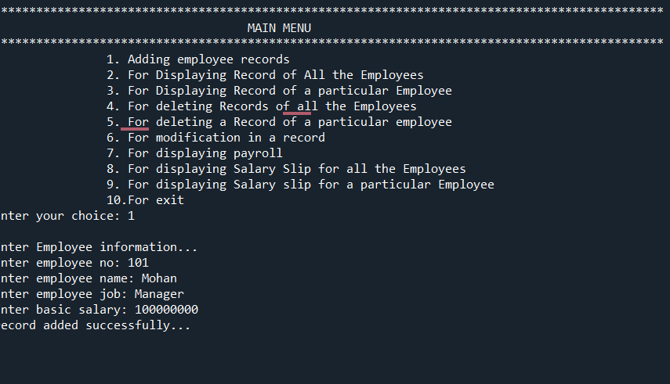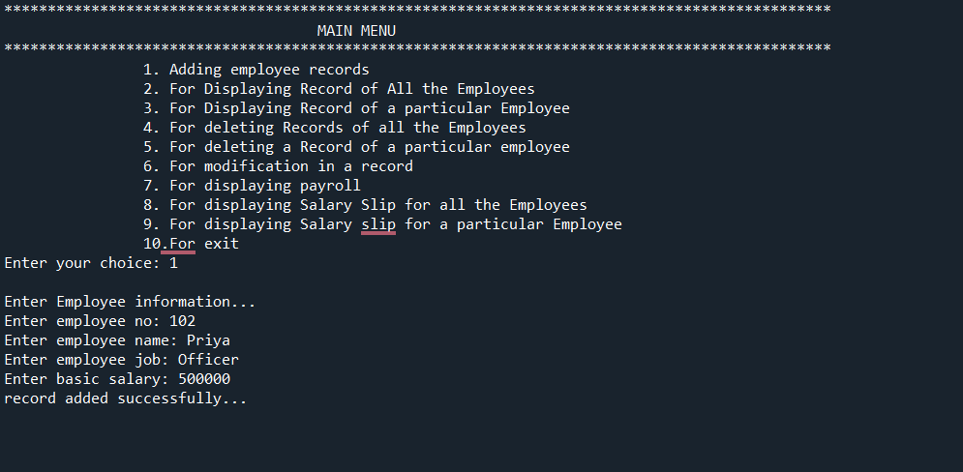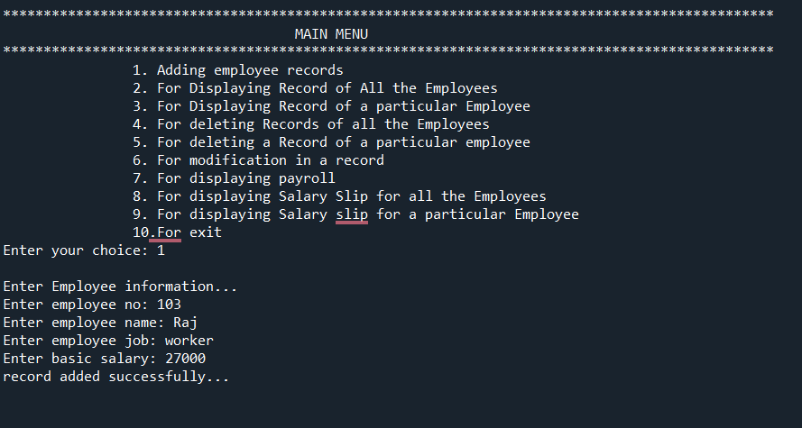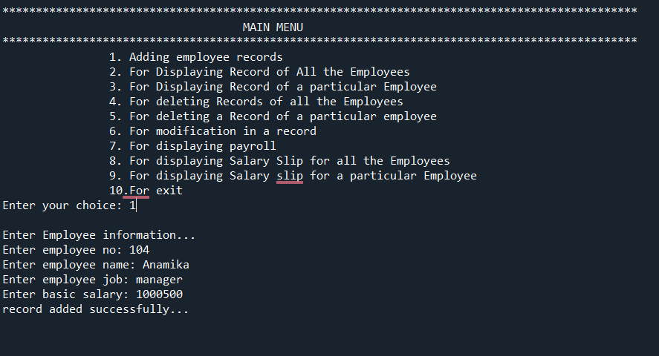

On choosing option 2
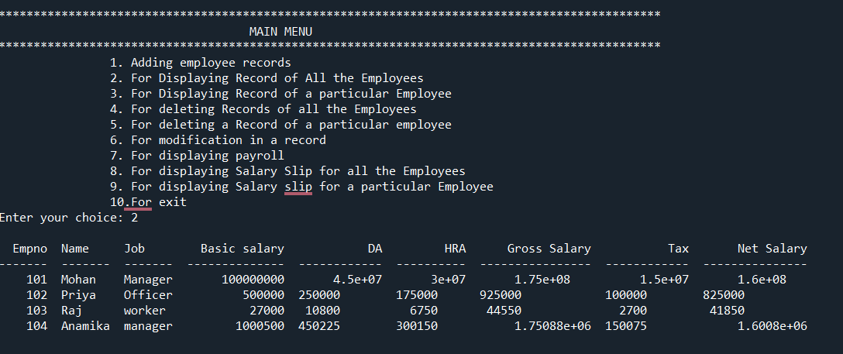
On choosing option 3
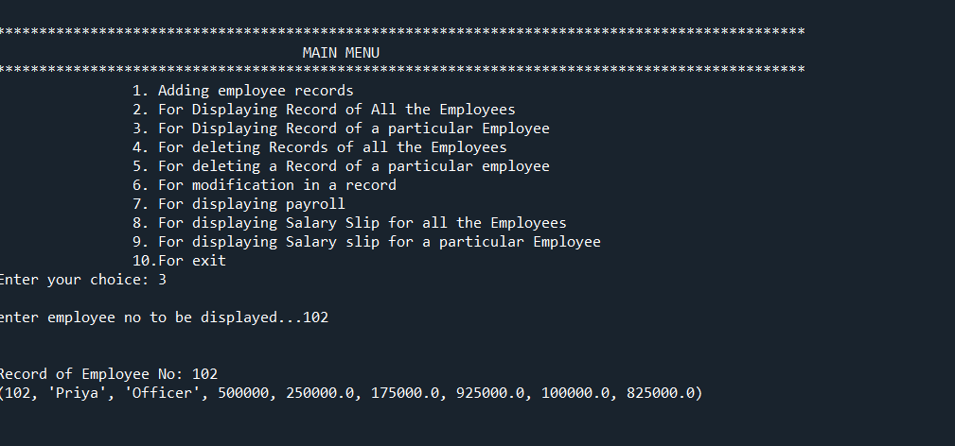

On choosing option 4
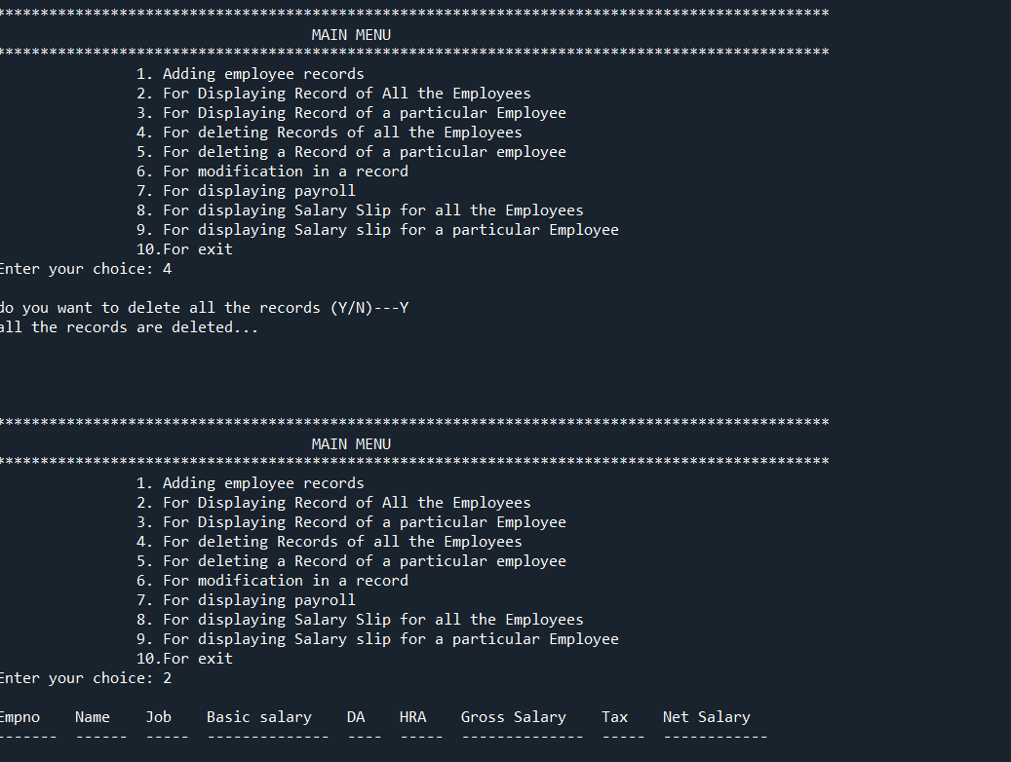

On choosing option 5
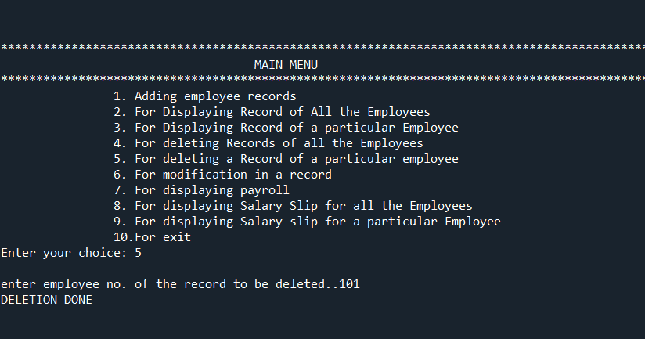
To check
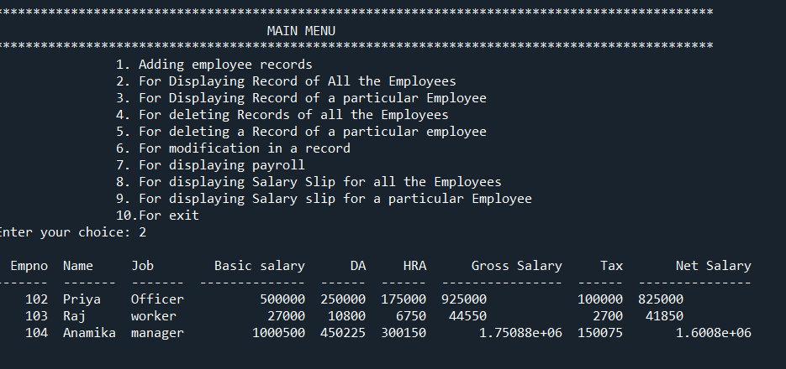

On choosing option 6
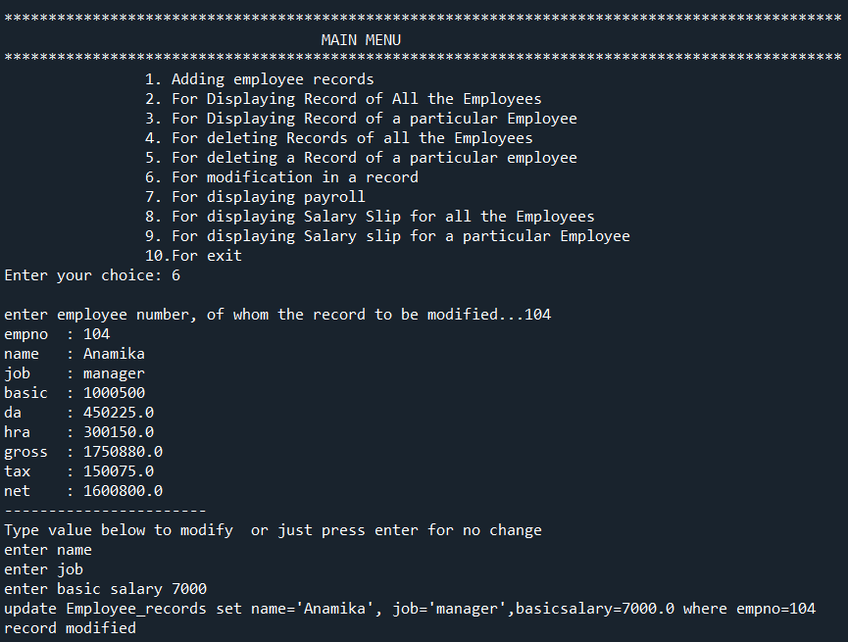
On choosing option 7
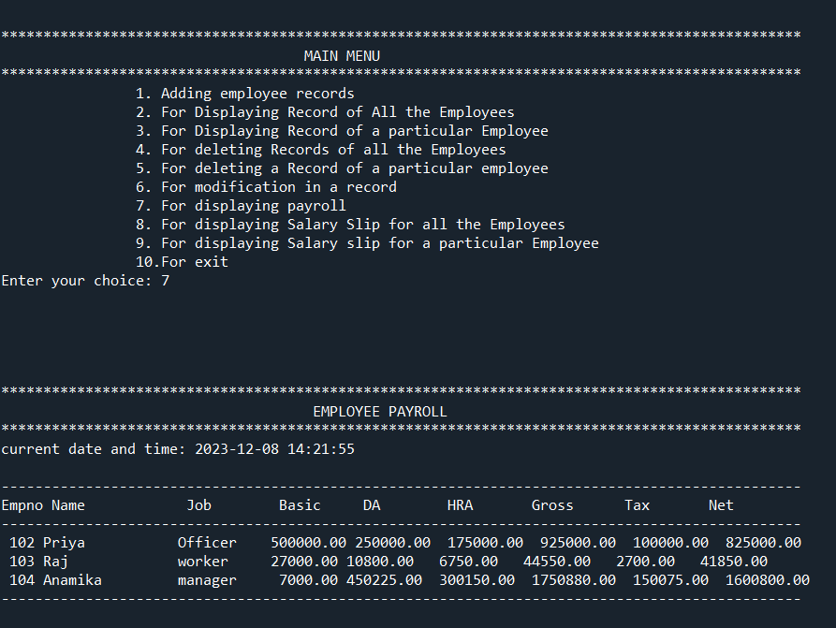
On choosing option 8
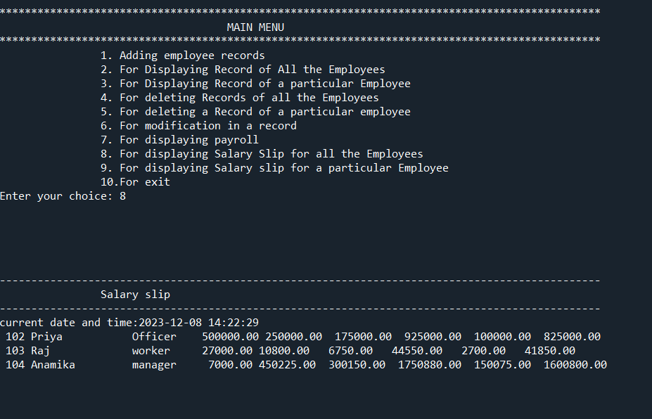

On choosing option 9
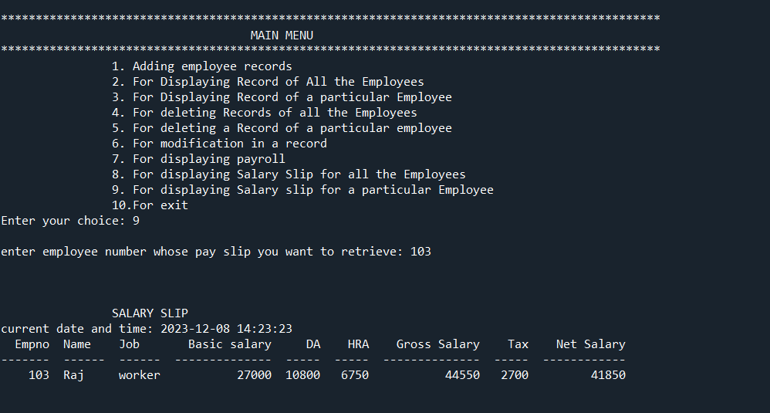
On choosing option 10
